MultiGlycan ESI

User Manual

1. Download

User can download the latest “MultiGlycan ESI” from our website

http://darwin.informatics.indiana.edu/MultiGlycan/

1. Installation
   1. Unzip

Unzip downloaded file to a folder. Two files, MultiGlycan.msi and setup.exe, will be in unzip folder.

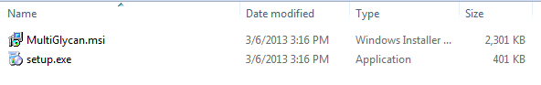

* 1. Setup

Double click on setup.exe to start installation wizard.

* + 1. Click “Next “ button

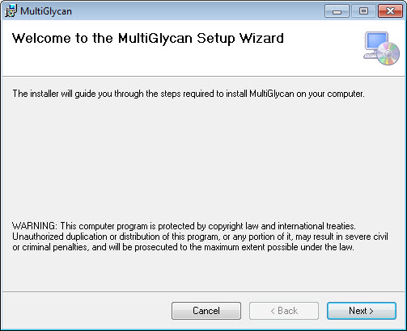

* + 1. Select installation folder

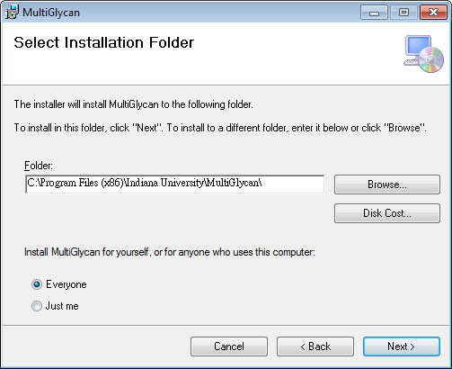

* + 1. Click “Next” to confirm installation

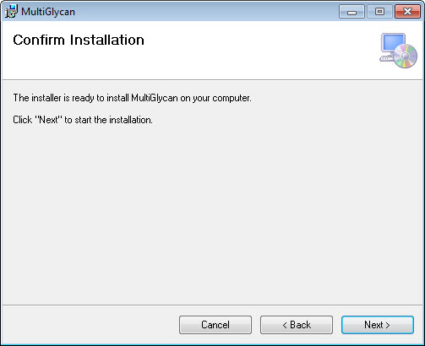

* + 1. Wait until installation complete

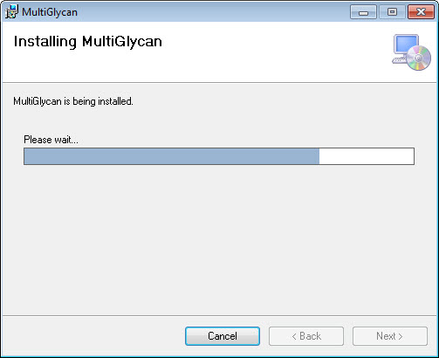

* + 1. Click “Close” to close installation wizard

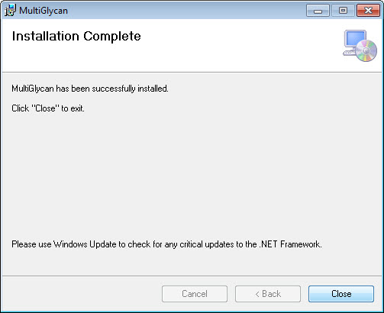

1. Start MultiGlycan ESI

Click “MultiGlycan ESI” shortcut on desktop or from Start menu

|  |  |
| --- | --- |
| D:\Dropbox\@Paper\MultiGlycan\Manual\Icon.jpg | D:\Dropbox\@Paper\MultiGlycan\Manual\StartMenu.jpg |
| Desktop shortcut | Start menu -> Indiana University (COL) -> MultiGlycan ESI |

1. Software interface

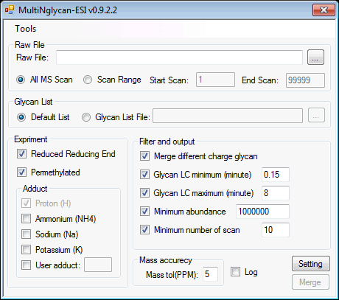

* 1. Raw File

Raw File: MultiGlycan supports .mzXML or .raw (Xcalibur needs to be pre-installed) LC-MS files

All MS Scan: MultiGlycan will process all scans in the file

Scan Range: MultiGlycan will process only scans in scan range

* 1. Glycan List

Default List: MultiGlycan will use the default glycan list (Default_Combination.csv within the software installation folder).

Glycan List File: Users can provide their own list in Comma-separated values format.

Please use “HexNAc,Hex,deHex,Sia” at the beginning of the file as the header.

Each line represent a glycan composition, and each composition should be separated by a comma “,”;

Example:

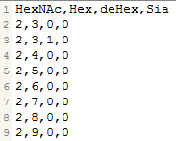

* 1. Experiment

Reduced Reducing End: Set to check if targeted glycans are reduced reducing end

Permethylated: Set to check if targeted glycans are permethylated

Adduct Information:

Proton (H): Proton always adds to glycans. This checkbox can’t be unchecked.

Ammonium (NH4): Check this checkbox, if ammonium is a targeted adduct

Sodium (Na): Check this checkbox, if sodium is a targeted adduct

Potassium (K): Check this checkbox, if potassium is a targeted adduct

User adduct: Check this checkbox and input the mass of user-defined adduct.

* 1. Filter and output

Two result files will be generated. The first is a full list of glycan identification in each scan and the other is a merged format of glycan identification results across all scans. The options below controls the merging of consecutively identified glycans into a single identified record

Merge different charge glycan: Merge identified glycans with different charge

Glycan LC minimum (minute): If the elution time duration of merged glycan is less than this number, this merged identification is ignored.

Glycan LC maximum (minute): If the elution time duration of merged glycan is greater than this number, the merged identification is split into two records.

Minimum abundance: If the merged glycan abundance is smaller than this number, the merged identification is ignored.

Minimum number of scan: If the scan count of the merged glycan record is smaller than this number. the merged identification is ignored.

* 1. Mass accuracy (PPM)

User can set the mass toleranace for matching.

* 1. Log

If checked, MultiGlycan will create a log of the whole process. This is for developer debugging purpose. If you encounter any exception please check this checkbox and send this log file to us.

Log file location: Installation path\log.txt

* 1. Mass Calculator

Mass calculator is a utiliy tool for computation of *m/z* given a glycan composition and adduct mass for different charge states. It can be accessed from Tools->Mass Calculator

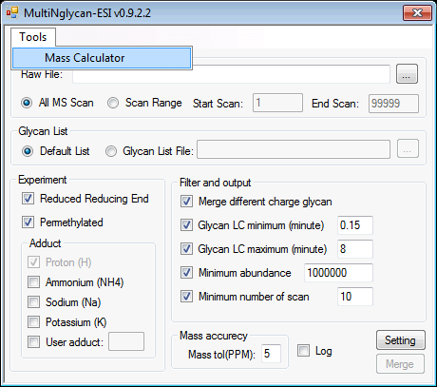

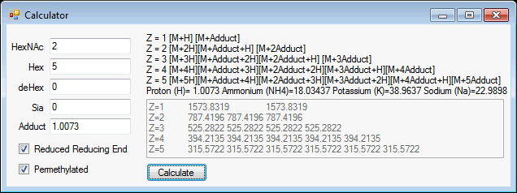

HexNAc, Hex, deHex, Sia: Input glycan composition

Adduct: Adduct mass

1. Result

Two result files are generated, the first is merged result and the second is the full list of identified glycans for each scan. The full result file will contain “_FullList” in output file name. Result files are both in CSV format.

Full list result file

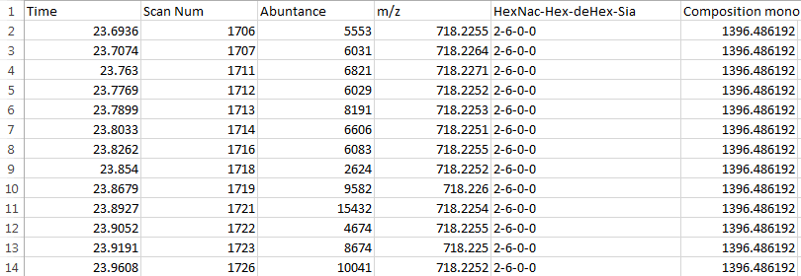

Time: Elution time of identified glycan

Scan Num: Elution scan number of identified glycan

Abundance: Abundance of identified glycan

*m/z*: mass-to-charge ratio of identified glycan

HexNAc-Hex-deHex-Sia: Glycan composition of identified glycan

Composition mono: Monoisotopic mass of identified glycan

Merged result file



Start Time: Start elution time of merged glycan

End Time: End elution time of merged glycan

Start Scan Num: Start elution scan number of merged glycan

End Scan Num: End elution scan number of merged glycan

Charge: Charge of merged glycan

Abundance: Abundance of merged glycan

HexNAc-Hex-deHex-Sia: Glycan composition of merged glycan

Composition mono: Monoisotopic mass of merged glycan